**Automation Documentation**

Steps to use the Executable files.

1. First, check your PC and determine if Java is installed and which version of Java it is. To do this, open the command (CMD) prompt. You can get to the command prompt in a few ways. If you have Windows, just type “CMD” in the Windows search box.

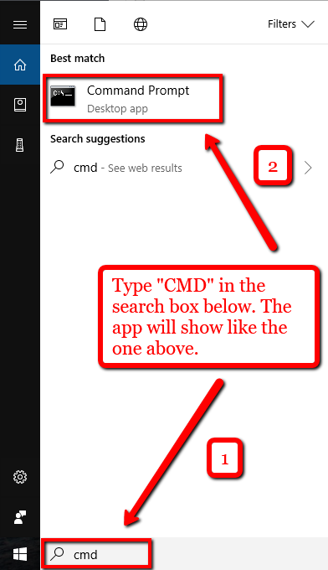

1. In the command prompt, type java -version (*see screenshot below*).

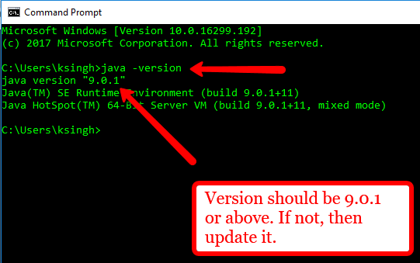

1. If your Java version is older than 9.0.1, then proceed to the next step to update. (*If no update needed, then proceed to step 5*)
2. Navigate to [www.java.com](http://www.java.com) and click on the “free Java Download.”

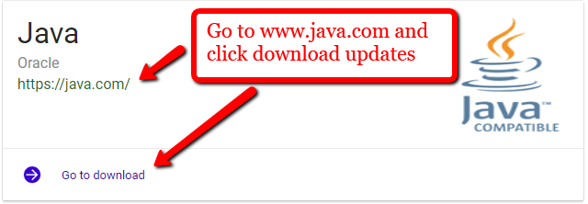

1. Next, in the Automation folder, there is a JDK that needs to be installed in order to run the executable files. The JDK application is provided in the mmi_automation folder. The path to the link is below. *mmi_automation\mmi_auto_testing_AdvancedSearch\data*

You may also get this download directly for the Oracle site link below. [Download JDK Application](http://www.oracle.com/technetwork/java/javase/downloads/index.html)

1. Next, you will need to download an older version of Firefox. If you already have Firefox then you will need to downgrade the version in order for the executable files to work correctly. The latest version of Firefox has security updates that deny automated entries of log in passwords and so the browser must be downgraded to an older version.
   1. First, uninstall Firefox from your computer. You can navigate to the search box and type *uninstall*. Go to the *Add or Remove programs* section. Look for “Mozilla Firefox” and click the uninstall button next to it.

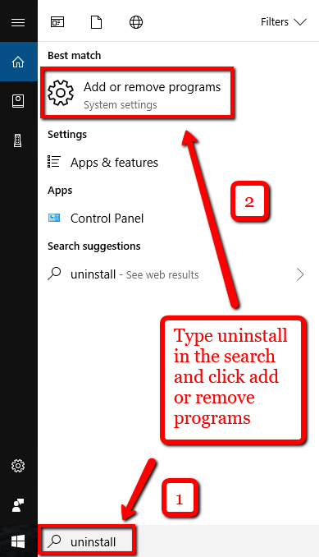

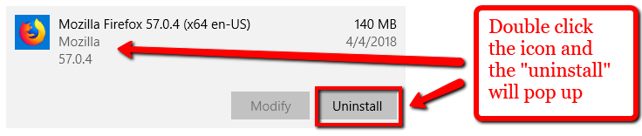

1. Once Firefox is uninstalled, proceed to the same folder above, “*mmi_automation\mmi_auto_testing_AdvancedSearch\data.*”

In this folder, you will find a Firefox setup 57.0.4. You may search the web for an even older version but Firefox 58 and above will not accept automation for passwords.

1. Follow the steps to download the Mozilla Firefox browser.

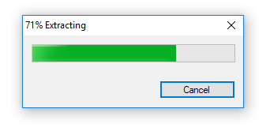

* 1. 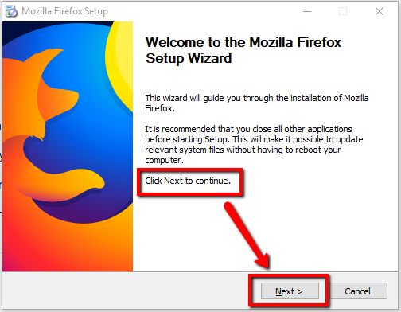
  2. 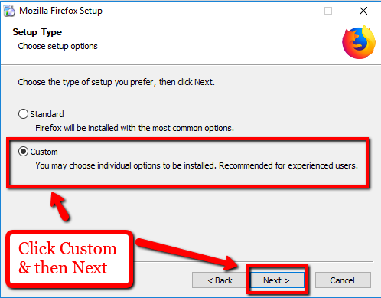
  3. 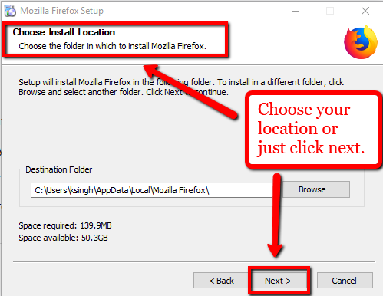
  4. 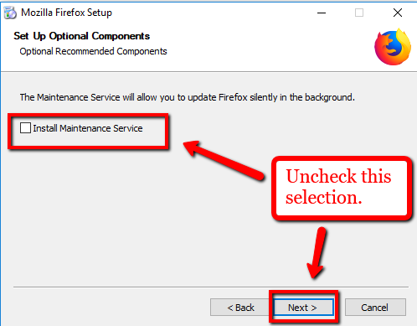

Be sure to Uncheck the “Install Maintenance Services” as this will want to update automatically to the latest version.

(we don’t want that)

* 1. 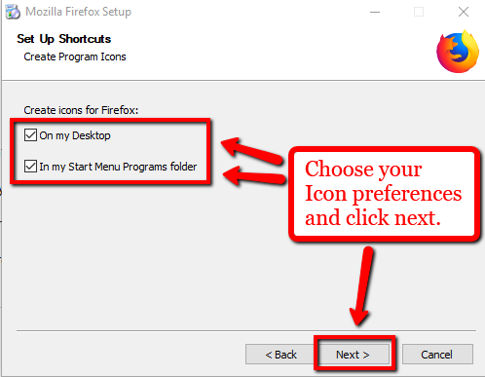
  2. 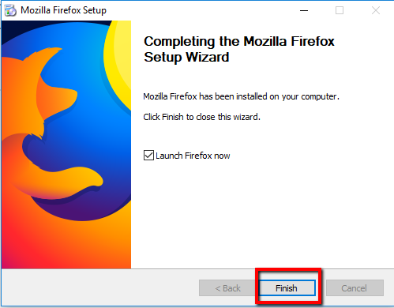

1. After downloading the older version of Firefox, navigate to the settings tab for the Firefox browser. (see screenshot below)
   1. 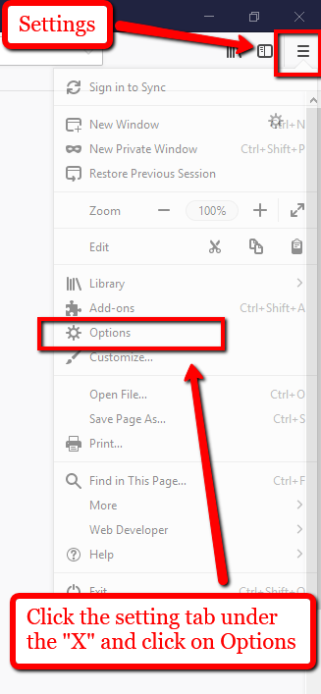
   2. 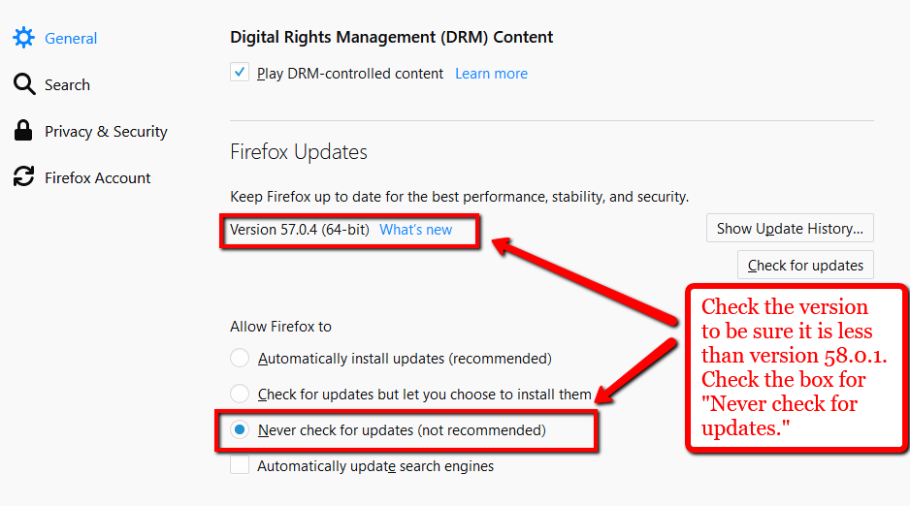
2. Once you have completed the prior steps, proceed to the mmi_automation folder provided. In this folder, you will see a sub folder called mmi_auto_testing_AdvancedSearch. This is where the bulk of the material is located. This sub folder has 3 more folders within called *bin*, *data* and *output*. Ignore the output folder for now. Click on the data folder and open the excel file called “AdvancedSearch_SEAutoTesting” or “Reports_Advanced_search.” One is Aveva and the second is for Lenovo reports.
3. Go the “BIN” folder and double click one of the executable files. It should run automatically if you downgraded Firefox correctly. If not, then there may be an issue with the browser or automation script.